
END FED 80 to 10 meter Antenna Matchbox Project
Introduction
As you know, the major problem with an end fed half wave antenna is that the antenna presents a very high impedance creating a significant miss-match with the usual transceiver impedance of 50 ohms. The magnitude of the miss-match is significantly greater than a typical tuner can accommodate.
This project constructs a 9:1 UNUN (unbalance to unbalance) toroid matching transformer that will reduce the very high input impedance of a long wire (17’ to 65’) end fed antenna down to the range of 1:2 to 1:4 over the range of 80 meters (3.5 mhz) to 10 meters (29.7 mhz). Using a properly designed UNUN at the feed point of the long wire end fed antenna will result in a low SWR match of 1:4 or less, where virtually all transceiver internal tuners can tune out the resulting difference very easily.
If your rig does not have an internal tuner, the matchbox can still bring your favorite band down to less than 1:2 SWR by building it as described, and then fine tuning the length of the long wire to obtain the desired SWR.
Matchbox Parts List
1 T130-2 Powdered Iron Toroid
1 2” x 2” x 4” fiberglass handy box and blank cover
3 24” pieces of 18 gauge solid insulated copper wire in red, green, black
4 6/32” x ½” machine screws and nuts
1 6/32” x ¾” machine screws and nuts

6 #6 flat washers
6 #6 lockwashers
2 ¼” x 20 x ¾” long Hex bolts and nuts
2 ¼” flat washers
2 ¼” lockwashers
2 ¼” wingnuts
3 Large wire lugs to fit ¼” bolt
1 Small wire lug to fit 6/32” machine screw
1 SO-239 panel mount (4 hole flange) connector
17’ 18 gauge stranded black wire for antenna. 17’ minimum
3” ½” CPVC pipe to make end antenna insulator
1 PVC ½” plug

Additional Part for Bream Pole Mounting
1” by by 1” by ½” PVC Tee

Preparing the MATCHBOX Fiberglass Enclosure

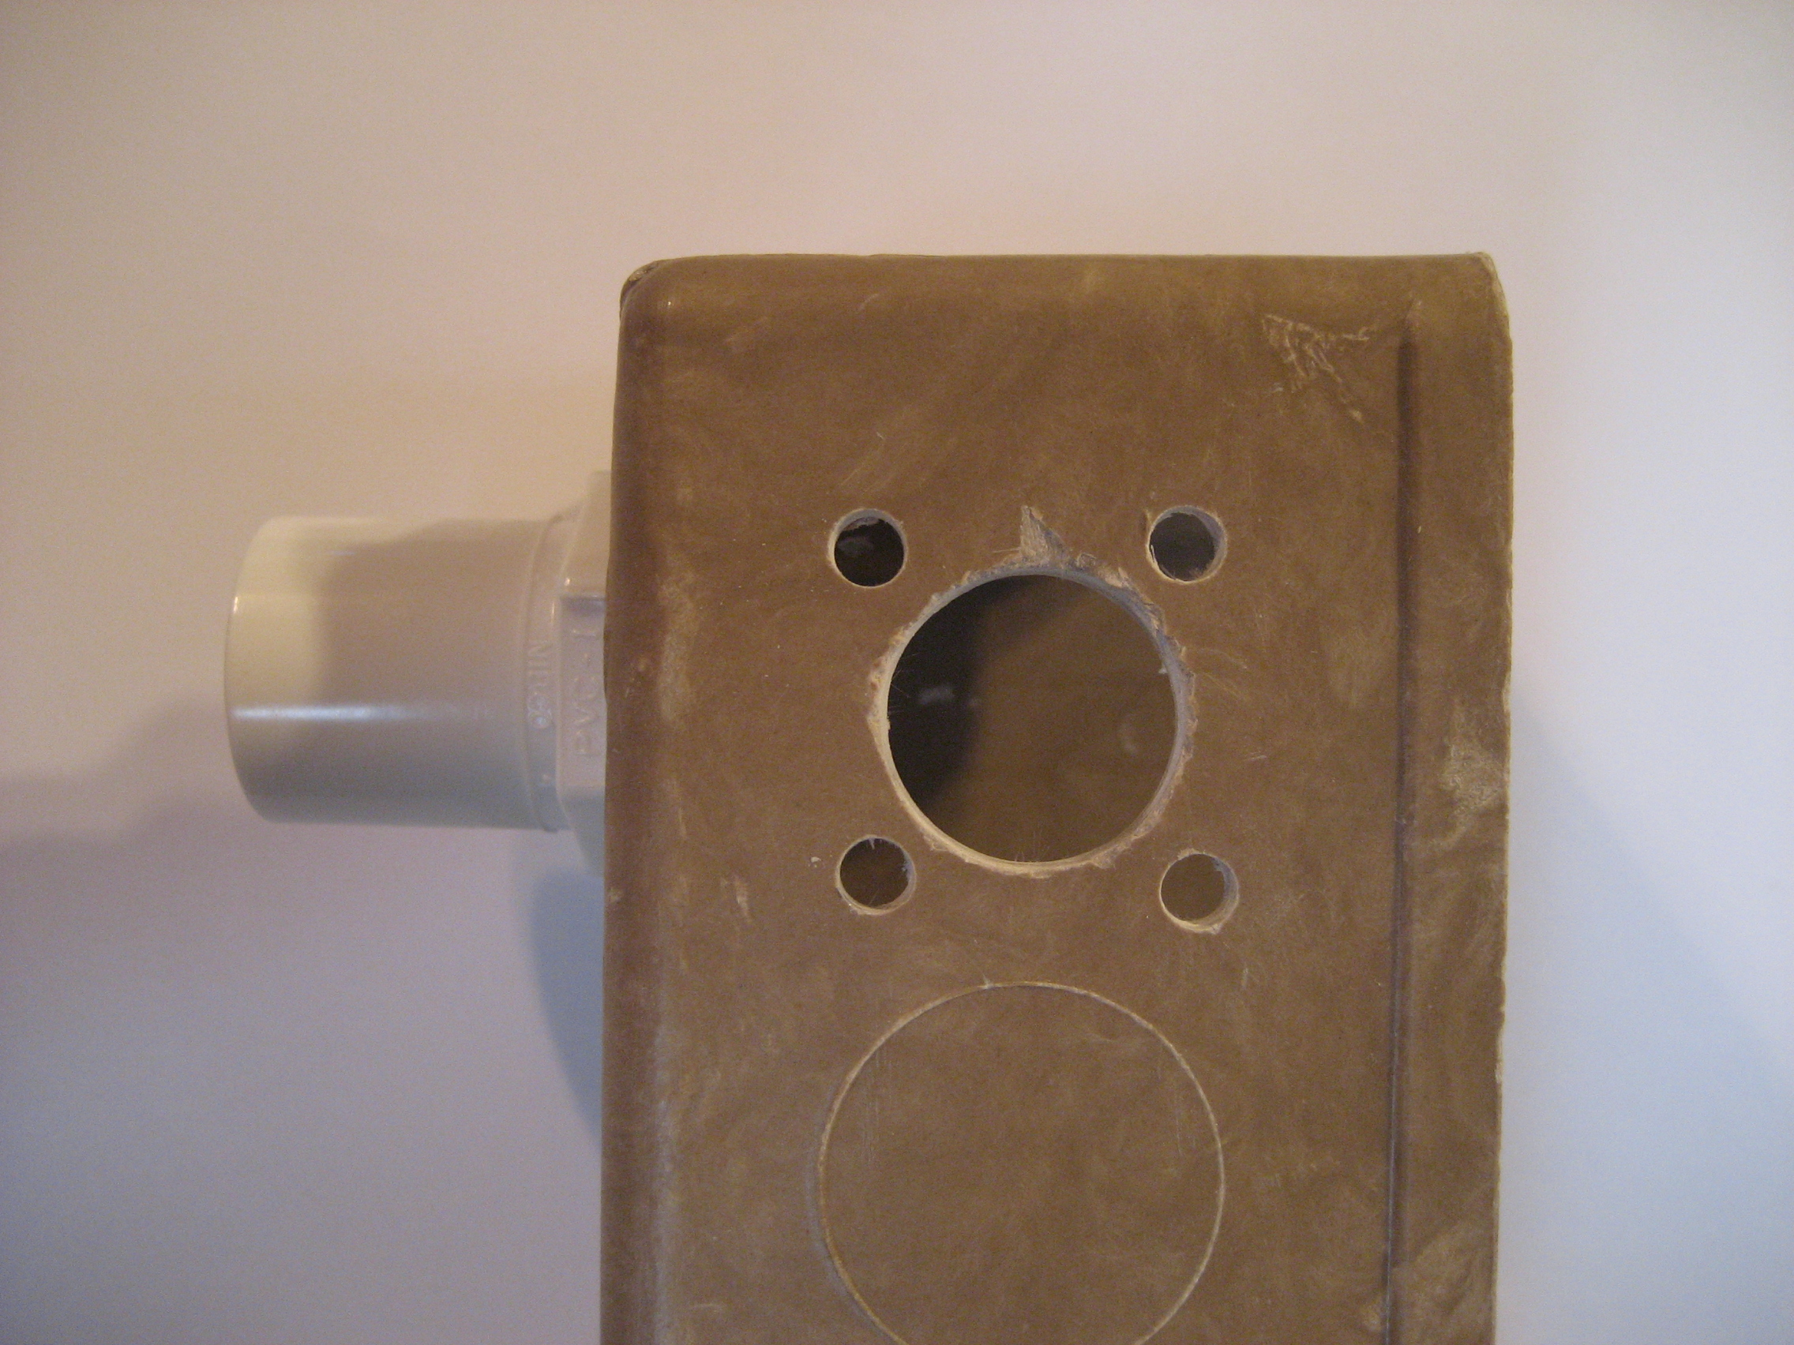
Start the project by mounting the ½” PVC plug to the upper rear of the fiberglass handy box using a 6/32 x ¾” machine screw, nut and two flat washers and two lock washers as shown in the photo on the right.

As shown in the photo to the right, , on the left side top half, drill one 5/8” hole and four 6/32” holes for mounting the SO-239 coax connector. Use the connector as a guide to mark for accurate drilling of the four smaller holes.

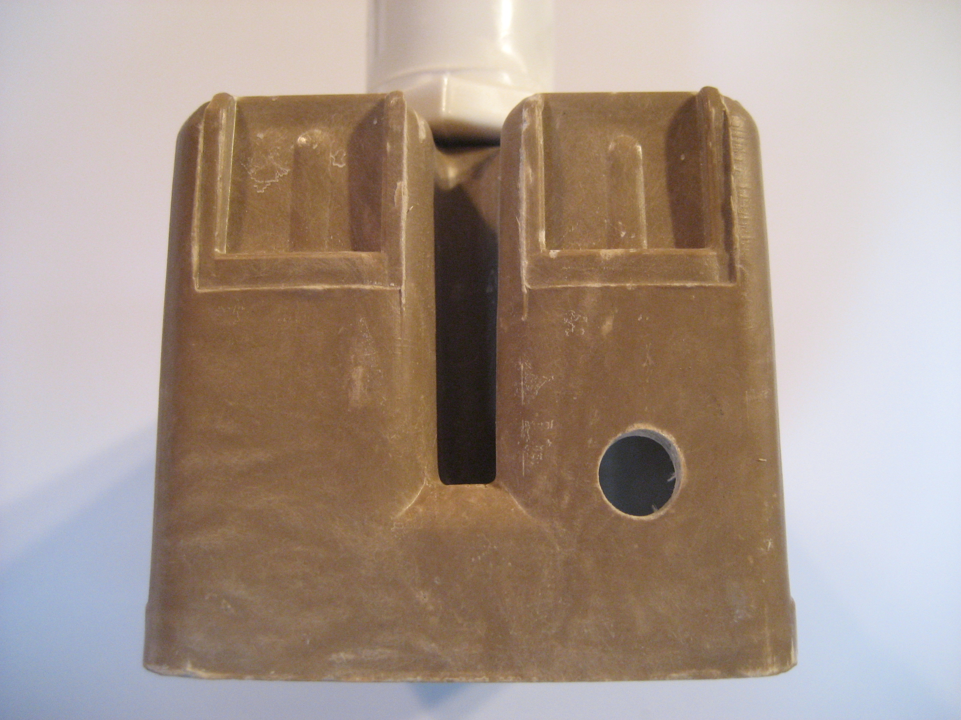
Drill a ¼” hole in the top right front and bottom right front (straight below) of the box for mounting of hex bolts for antenna and ground connections as in the photo on the left.

This shows the placement of the ¼” hole for the antenna connector. The ground connector is straight down at a corresponding position on the bottom of the box.

TOROID WINDING
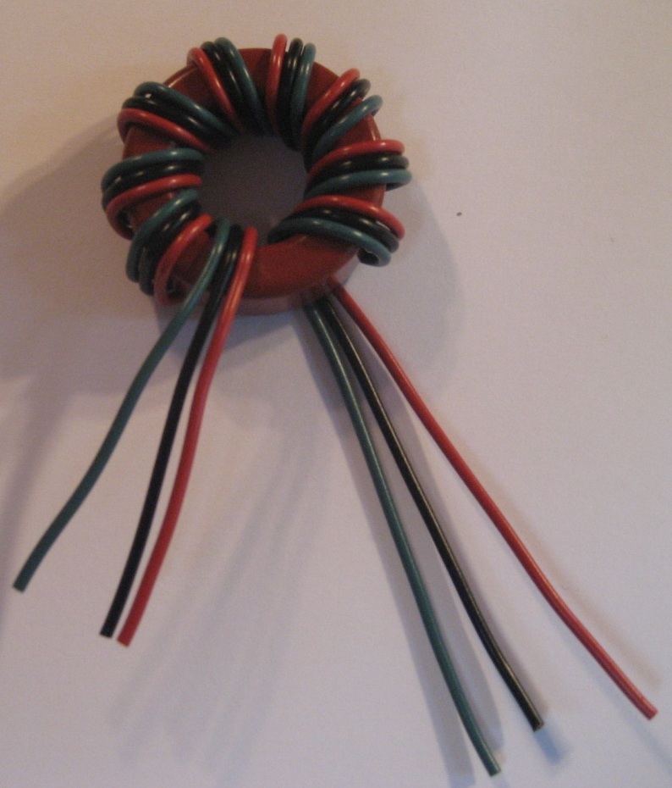
Next wind the three 24” pieces of 18 gauge solid copper wire onto the T130-2 toroid. Place the wires (left to right) green-black-red, and wrap the toroid 9 turns so that it looks like the left photo.
Notice in the photograph there are three wires extending from the left winding and three wires extending from the right most winding. As we finalize the connections I will refer to the specific wires by left or right and color.
In the next step, we need to trim, crimp together and solder the left black wire with the right red wire. When the step is completed, it will look like the photo below:
Note that the left red and green wires and the right black and green wires have been moved slightly to facilitate the connection and soldering and to make the completed step more visible.

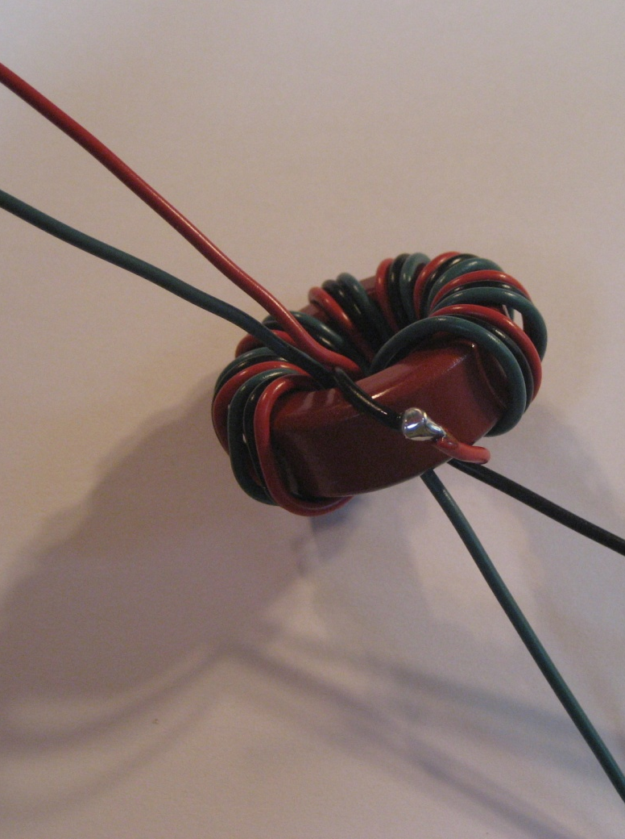
The next three steps should appear as shown the photo below. Attach by crimping and then soldering a large lug to the left red wire about 4” from the toroid. The completed lug will later connect to the antenna connection hex bolt on the top of the fiberglass box.
Twist the left green wire with the right black wire. Strip the ends of the two wires, twist and solder together at about 2”. These two wires will be soldered to the center connection of the coax fitting during final assembly into the fiberglass box.
Trim and strip the remaining right green wire and another 5” piece of green solid wire. Using a small lug, crimp both wires securely into the lug and solder. This small lug will connect through a 6/32 machine screw to the ground of the coax connector. Strip the remaining end of the 5” green wire and crimp and solder on a large lug. Your completed toroid should look like the photo below.
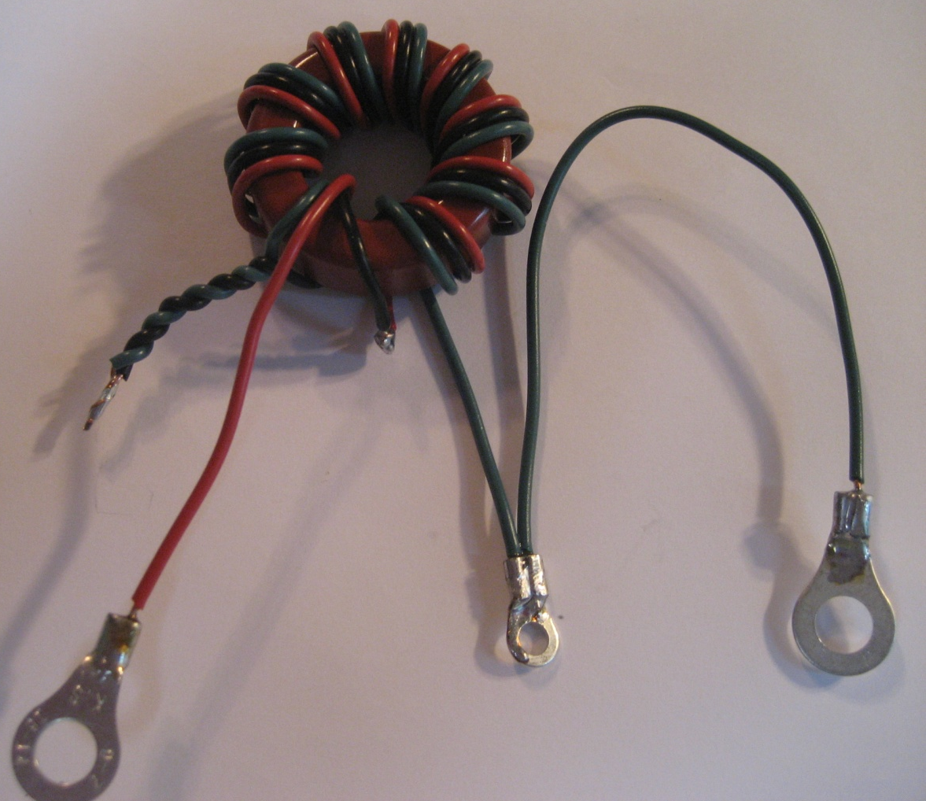
As shown on the next page,
the final soldering step is accomplished by placing the toroid inside the mounting box and pushing the twisted green and black pair of wires through the 5/8” mounting hole for the coax connector. Solder the pair of wires to the center SO-239 coax connector as shown in the photo below.

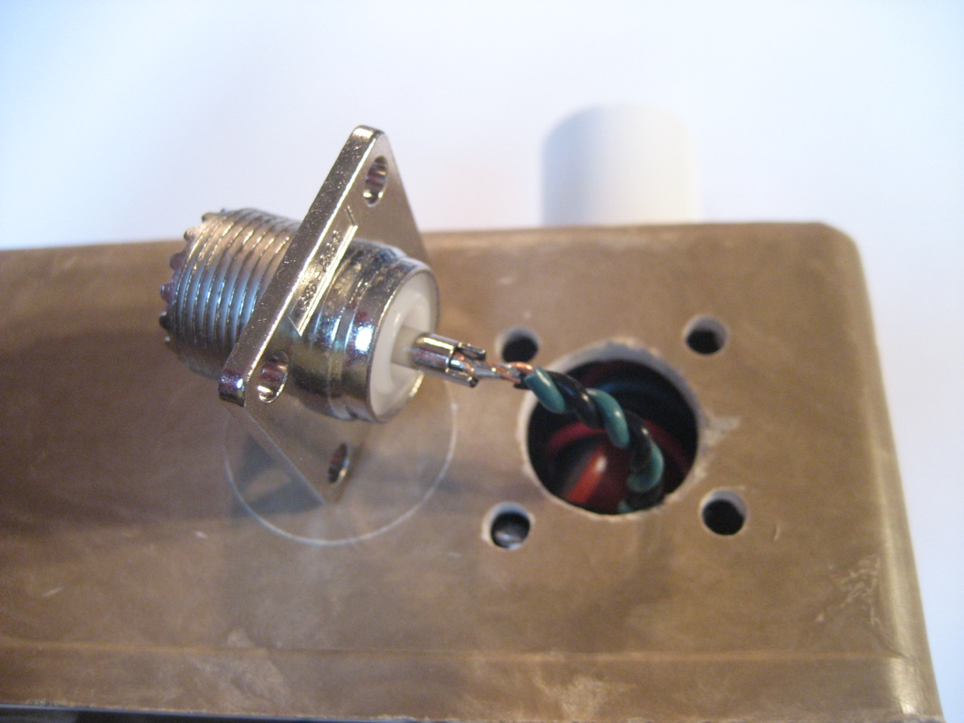
With the center coax connection soldered, you are now ready to perform the final assembly of the matchbox.
Gently position the coax connector in position over the mounting holes. Place a 6/32 x ½” machine screw through the connector and fiberglass box. On the inside, place a flat #6 washer and a # 6 lockwasher over three of the machine screws, followed by a 6/32” nut. Tighten only finger tight. On the last machine screw place a flat #6 washer, the small lug connecting to two green wires, a # 6 lockwasher and a 6/32” nut.
Tighten all four machine screws securely. Position the toroid inside the box to allow connection of the antenna wire, the red wire, to the top ¼” x 20 hex bolt, and the ground wire, the remaining green wire to the lower ¼” x 20 hex bolt.
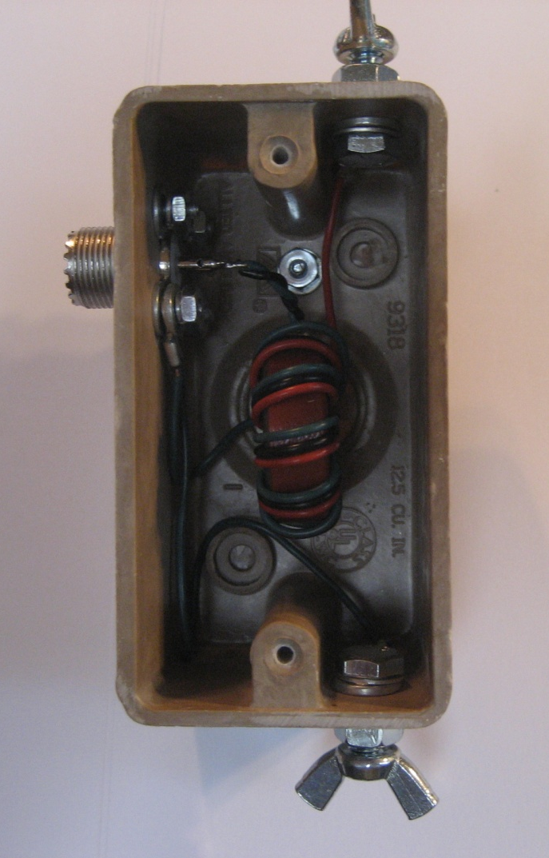
Place a hex bolt through the respective large lug connector, a ¼” lockwasher, and place the bolt through the top or bottom hole as appropriate followed by a ¼” flat washer and a ¼” nut. Tighten the nut sufficiently to compress the lockwasher on the inside. After the red wire has been connected to the top hex bolt and the green wire has been securely connected to the bottom bolt, place a ¼” wing nut on each protruding bolt. The project should generally appear as shown left.
Assembling the Antenna Wire
The next step is to assemble the antenna wire itself. At one end of the 3” CPVC pipe section, drill two 3/32” holes about ½” apart. These holes serve to hold the antenna wire. Loop the wire through the holes as shown. At the other end of the PVC pipe, drill a ¼” hole thru the pipe to serve as a connecting point for nylon cord to support this end of the antenna. If you intend to use traditional

